CTF Topic: Redirecting Java API Calls with JavaAPI-Redirector Firefox Extension

Introduction

JavaAPI-Redirector is a Firefox extension that allows users to intercept and redirect Java API calls. This can be useful for testing and debugging Java applications by observing how they handle API redirects.

Tools and Requirements

- Mozilla Firefox browser  
- Install the [JavaAPI-Redirector Firefox extension](<https://addons.mozilla.org/en-US/firefox/addon/javaapi-redirector/?utm_source=addons.mozilla.org&utm_medium=referral&utm_content=search>)   
- Basic understanding of Java API calls and web development

Scenario

As a participant in this CTF challenge, your task is to use the JavaAPI-Redirector Firefox extension to intercept and redirect Java API calls for `<http://testphp.vulnweb.com/> `. Perform the redirection and answer the following questions based on your findings.

Begin

1. Install the JavaAPI-Redirector Firefox extension from the provided link.  
2. Visit `<http://testphp.vulnweb.com/> ` and use the extension to intercept and redirect Java API calls.  
3. Utilize the extension features to answer the questions.

Questions and Answers

Flag 1: Use the extension to intercept Java API calls on `http://testphp.vulnweb.com/`. How many API calls are made by the webpage?

Answer:

Number of API calls made: 1

Flag Captured.

Flag 2: What is the response status code of the redirected API call?

Answer:

Response status code: 200

Flag Captured.

Hint

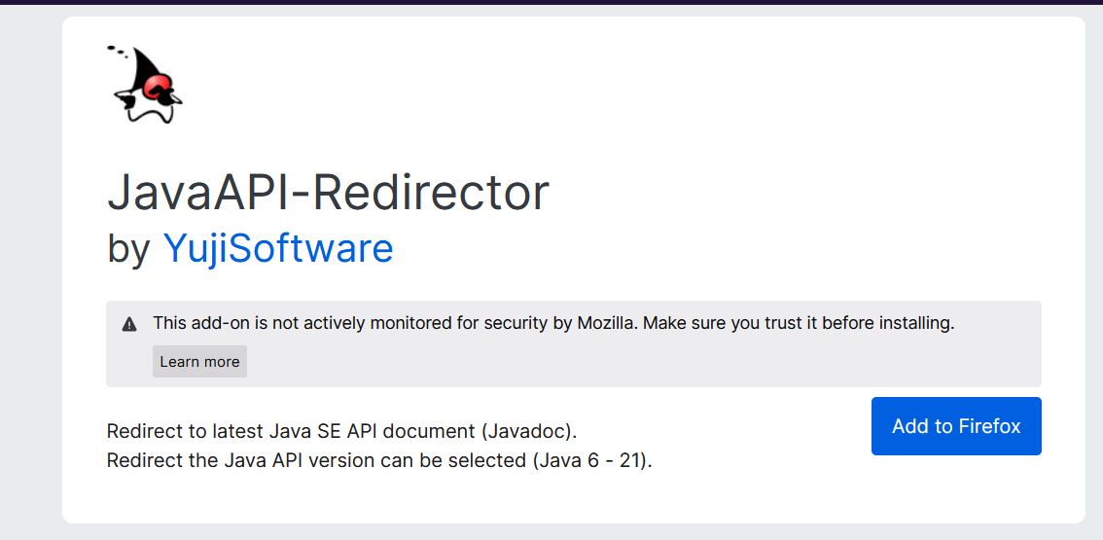

Install the JavaAPI-Redirector Firefox extension and use it to intercept, redirect, and modify Java API calls for `http://testphp.vulnweb.com/`. Pay attention to the details of each operation to answer the questions accurately.